

AI Assisted Problem Solving Using Python

AcademicYear:2025-2026

Assignment Type: Lab
Assig_No. 3

Submitted by:
Name: NUKALA MEGHANA SRI
Enroll No.2503b05113
Course: M-Tech CSE

Submitted to:
Name: Venkataramana Veeramsetty
Title: Course Instructor

Date: 28 Oct 2025

Objective:
To develop a Python program that calculates the electricity bill for TGNPDCL customers
based on energy consumption and customer type using AI tools such as GitHub Copilot.
Problem Statement:
The program reads previous and current meter readings (PU, CU) and the type of customer.
It calculates energy charges (EC), fixed charges (FC), customer charges (CC), electricity
duty (ED), and displays the total bill amount similar to a real TGNPDCL power bill.
Python Source Code

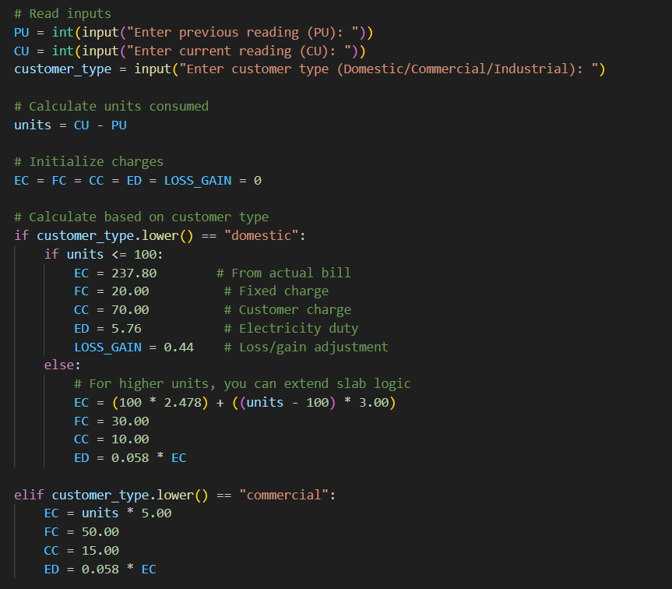
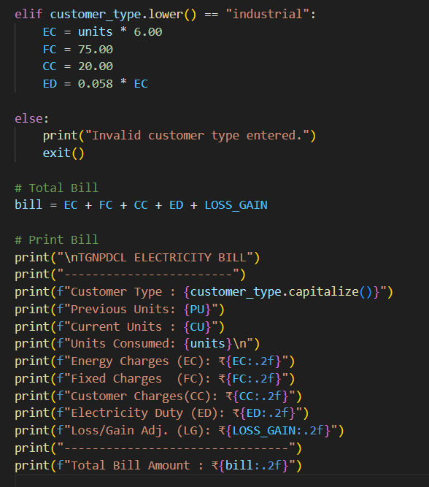
Output Screenshot:

